

Mevaqqer Prof. Gregory Smith
www.hmisrael.com

To Whom it May Concern,

I am writing this letter on behalf of __________, a member of our assembly in good standing. Hebrew Messianic Israel objects to the Covid vaccination as a matter of deep religious conviction. Acts2Asssemblies is part of a denomination of assemblies across the world. Our headquarters are in Vero Beach Florida at this web-address - http://veroyahad.com/

Mr/Ms/Mrs ___________ has been subjected to a demand that she/he be vaccinated with the experimental Covid Vaccine in order to remain employed. The Mandate violates Essene Torah prohibitions against killing the unborn, benefiting from a human corpse, contaminating one’s body, incurring health risk, and undergoing unnecessary medical procedure. Elaboration about these religious objections follows parallel concerns about the proposed law's infringement of constitutional rights.

Forty-five states currently maintain religious exemptions and many have philosophical exemptions as well. No compelling reason therefore exists to breach 1st Amendment religious liberty by depriving people of their jobs and livelihoods. The proposed harsh, unfair, and unnecessary Covid Vaccine mandate violates constitutional rights, medical freedoms, informed consent, the Nuremberg Code, and treaty obligations.

The White house and Medical community should not rely upon the kind of "consensus" that "vaccines are safe and effective" as an excuse for bullying a perfectly healthy minority that does not present a threat to anybody. Especially when it has been shown in several news articles that certain numbers of people have harsh reactions/pervading health conditions (or even death) as a result of them. It is wrong to force people to inject liability-free pharmaceutical products whose safety even doctors and scientists from the World Health Organization have questioned "CAUGHT ON CAMERA: W.H.O Scientists Question Safety Of Vaccines" https://www.bitchute.com/video/xyiDFR2BDNNF/

"Take utmost care for yourself; and guard yourself scrupulously” (Deuteronomy 4:9) carries a prohibition against consuming or using anything that poses bodily contamination or health risk. Vaccines carry a risk of injury and death. Essene law does not permit risking ourselves or our children for a questionable greater good.

Respectfully yours,

Mevaqqer Prof. Gregory Smith,
235A Brooks Stuart Dr
Greenwood, South Carolina 29649

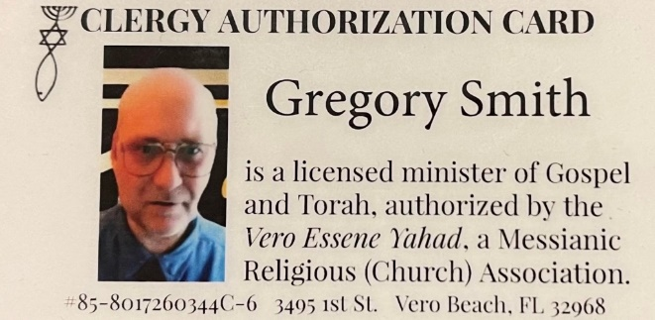

*Covid-19 Vaccines and Myocarditis Link Probed by Researchers – The Wall Street Journal By
Peter Loftus Nov. 7, 2021

*Covid-19 Vaccines and Myocarditis Link Probed by Researchers – The Wall Street Journal
By
Peter Loftus Nov. 7, 2021
CT **Aborted fetal cells are used in vaccines research and production. Top vaccine
developer Dr. Stanley Plotkin testified on January 11, 2018 that a single Wistar
Institute study involved the dissection of 76 fetuses older than three months
https://www.youtube.com/watch?reload=9&amp;v=bvBszdGBOxM These 76 fetuses comprise a
very small portion of the total number of fetuses used in vaccine research. Vaccines
themselves use much larger numbers of fetal components. Vaccine Ingredients that
incorporate fetal components include, but are not limited to, PER C6, HEK 293, IMR-
90, WI-38, WI-1 through WI-25, W-44, and MCR-5. Abortion is not allowed by Essen
Torah law. Dead fetuses are desecrated for the research and production of vaccines.
The Torah prohibits desecrating the dead (Deuteronomy 21:22-23). The Sages explain
that this law applies to all dead bodies in any situation. This prohibition derives from
respect for the vessel that contains a soul made in the image of God. The Torah
further prohibits gaining benefit from a corpse . Most authorities consider this a biblical
prohibition that precludes any kind of benefit . Vaccines contain non-kosher animal
cells, blood, and DNA along with foreign substances such as aluminum,
formaldehyde, and phenoxyethanol. The Torah teaches, “Take utmost care for
yourself; and guard yourself scrupulously” (Deuteronomy 4:9). Injecting such forbidden
substances directly into my bloodstream directly challenges Essene Torah teaching that
regards my body as the repository of a soul made in God’s image. &quot;Take utmost care
for yourself; and guard yourself scrupulously” (Deuteronomy 4:9) also means that it is
prohibited to consume or use anything that could pose a health risk to our bodies.
Vaccines carry a risk of injury and death.

CT **Aborted fetal cells are used in vaccines research and production. Top vaccine developer Dr. Stanley Plotkin testified on January 11, 2018 that a single Wistar Institute study involved the dissection of 76 fetuses older than three months https://www.youtube.com/watch?reload=9&v=bvBszdGBOxM These 76 fetuses comprise a very small portion of the total number of fetuses used in vaccine research. Vaccines themselves use much larger numbers of fetal components. Vaccine Ingredients that incorporate fetal components include, but are not limited to, PER C6, HEK 293, IMR-90, WI-38, WI-1 through WI-25, W-44, and MCR-5. Abortion is not allowed by Essen Torah law. Dead fetuses are desecrated for the research and production of vaccines. The Torah prohibits desecrating the dead (Deuteronomy 21:22-23). The Sages explain that this law applies to all dead bodies in any situation. This prohibition derives from respect for the vessel that contains a soul made in the image of God. The Torah further prohibits gaining benefit from a corpse . Most authorities consider this a biblical prohibition that precludes any kind of benefit . Vaccines contain non-kosher animal cells, blood, and DNA along with foreign substances such as aluminum, formaldehyde, and phenoxyethanol. The Torah teaches, “Take utmost care for yourself; and guard yourself scrupulously” (Deuteronomy 4:9). Injecting such forbidden substances directly into my bloodstream directly challenges Essene Torah teaching that regards my body as the repository of a soul made in God’s image. "Take utmost care for yourself; and guard yourself scrupulously” (Deuteronomy 4:9) also means that it is prohibited to consume or use anything that could pose a health risk to our bodies. Vaccines carry a risk of injury and death.

